**User Manual**

**For**

**Non-Formal Education**

**Management Information System**

**(NFE-MIS)**



**Non-Formal and Continuing Education Division**

**Department of Adult and Higher Education**

**Ministry of Education**

**March 2020**

Table of Contents

1. SSO login
2. System Management
3. Masters
   1. Actions
   2. Workflow
   3. Modules
   4. Sub Module
   5. Screen/Services
4. Role Privilege Management
   1. Role Management
   2. Role Priv. Management
5. User Management
6. Workflow
7. SSO Login

Enter your Email and Password to login

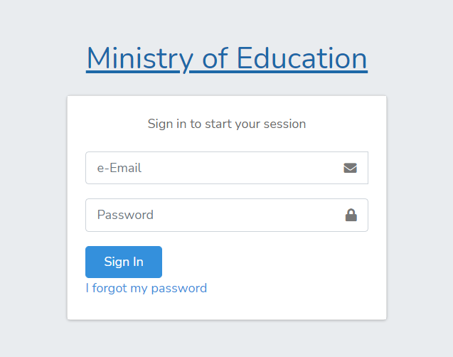

Enter Valid your valid email ID and provide password and then click on Sign In Button.

After Login you will be directed to the Module Landing Page

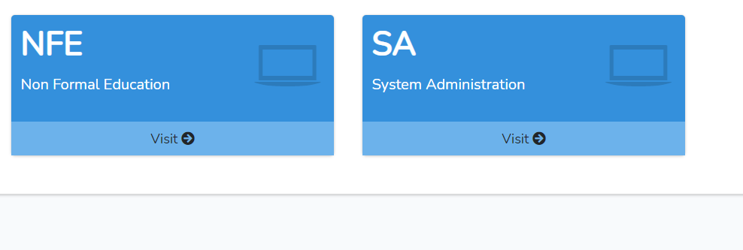

Select SA to go to System Administration Application

Upon selection of SA Application, you will Navigate to System Administration Application displayed below.

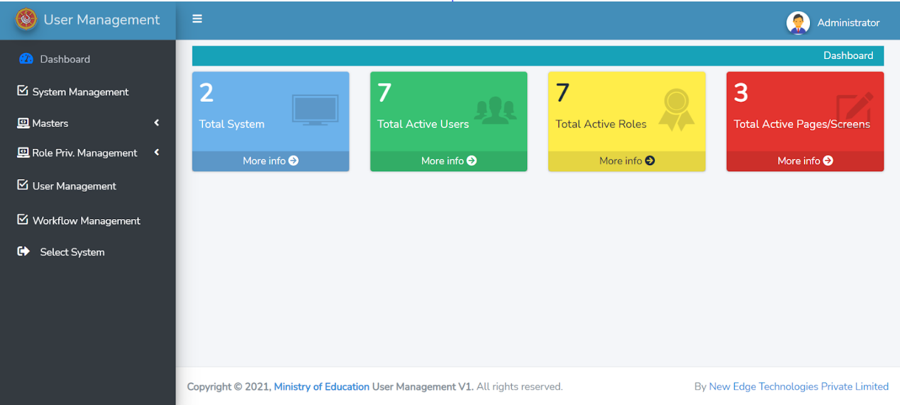

1. **System Management**

Step 1: Click system management button at the side menu  to display the list of existing system management Action List

Note:

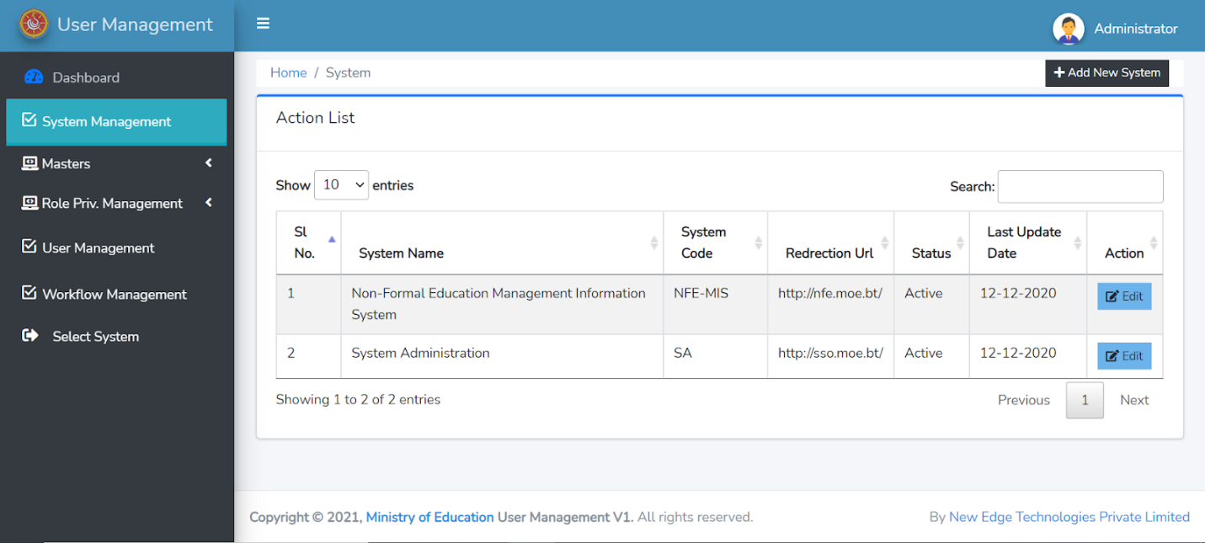

Step 2: click on Add New System to add new system



Upon click on Add New System, a form will pop up like displayed below. Fill in the necessary information below and click **OK**

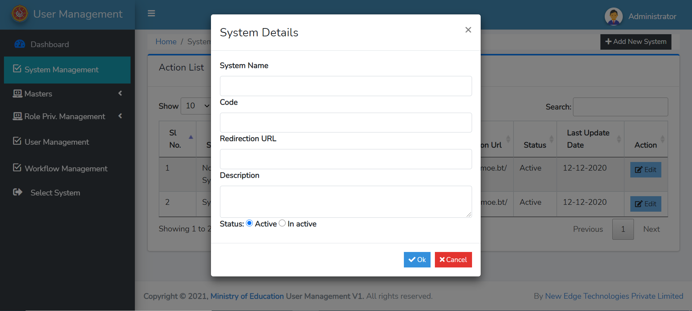

Step 3: Click on Edit Button to Modify or Change the details of existing System Management Information.



Upon click on Edit Button the form below will get displayed. Edit the required detail here and click **OK**

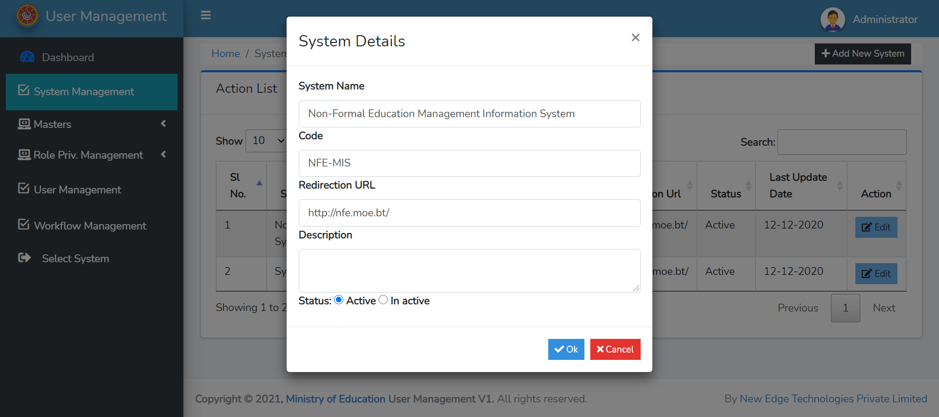

1. **Maters**

Step 1: Click on **Master** to display all the **Master Menu** shown below

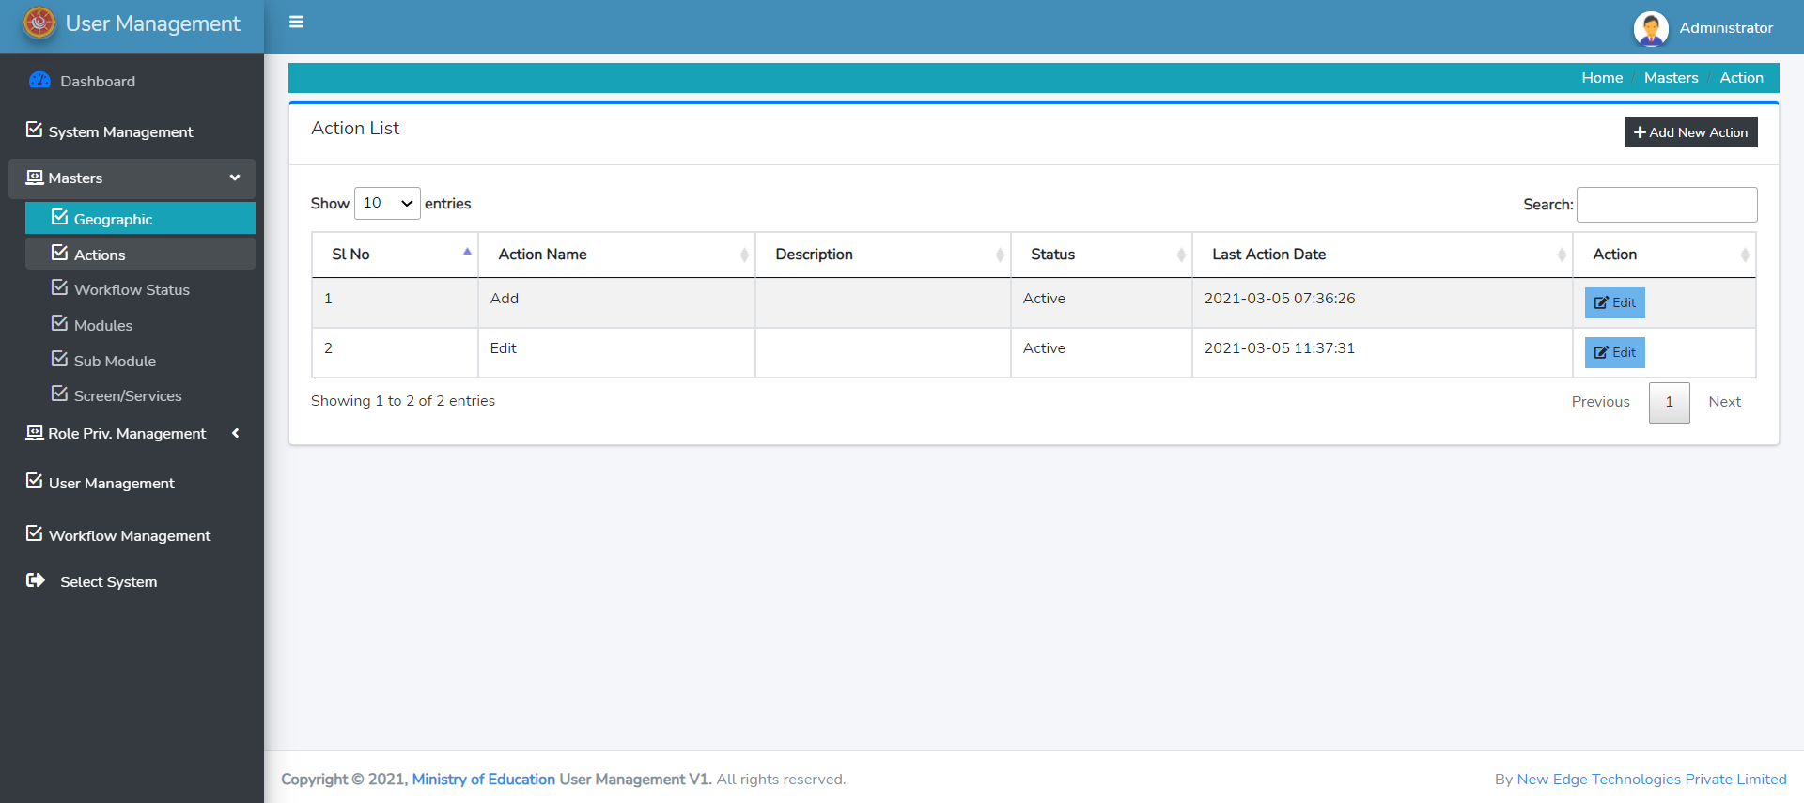

**3.1 Maters: Actions**

Step 1: Click on **Action** to display the existing Action List.



Step 2: On click of **Add New Action** Button a form will pop up. Fill in the Details and Click **OK.**



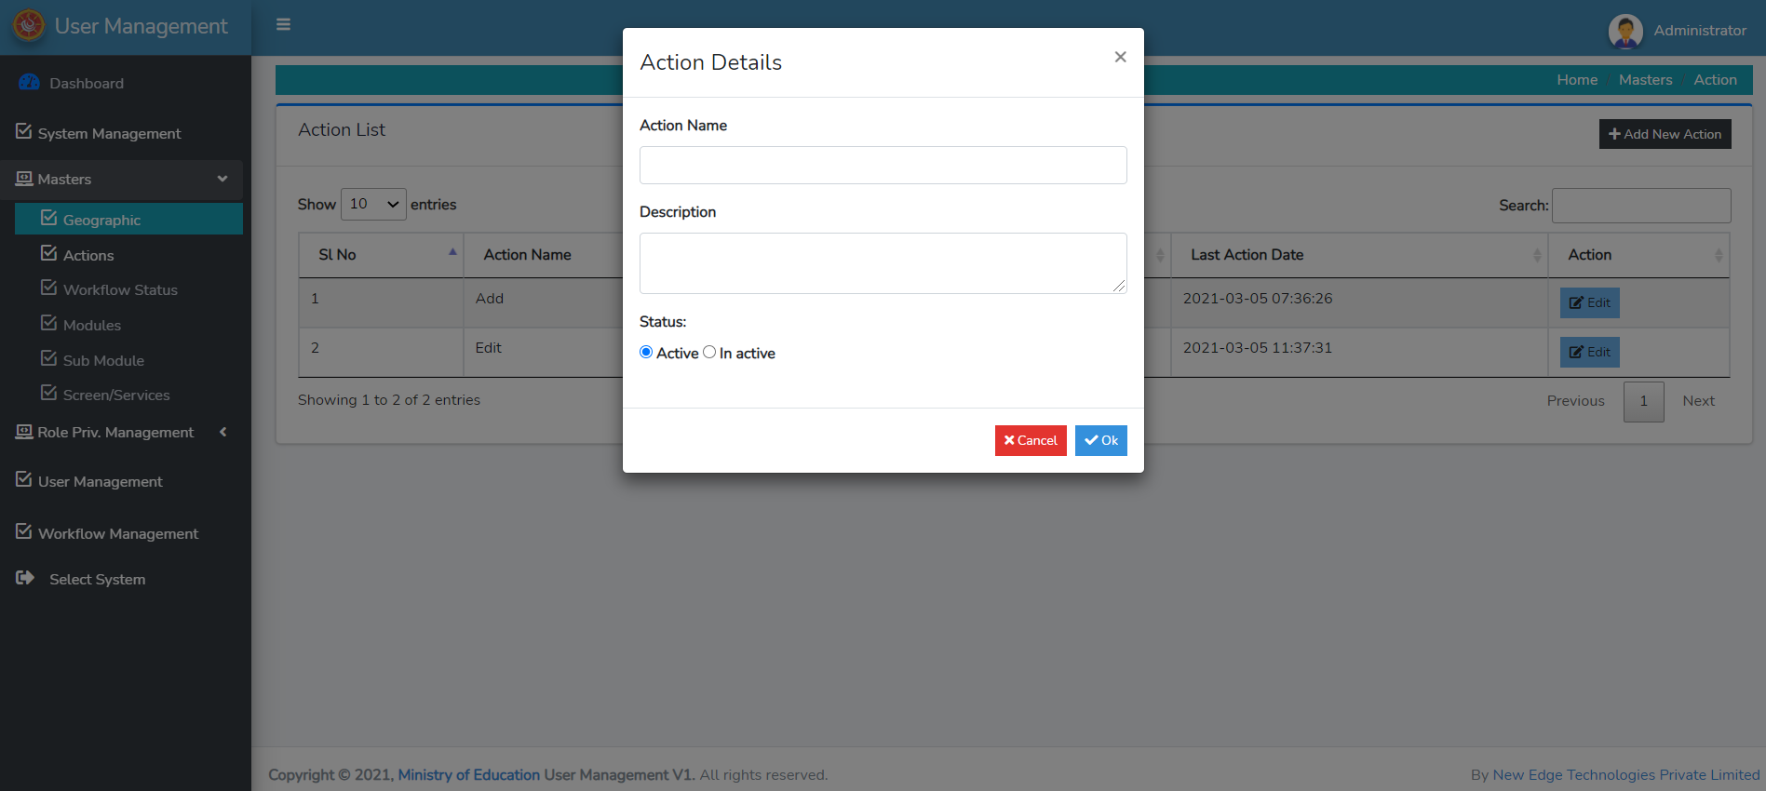

Step 3: Click on Edit Button to change or modify the existing Action.



Step 4: Click on **Edit** Button to edit the existing **Action** (e.g ADD, EDIT, DELETE). Upon click on Edit, the form below will pop up. Fill in the necessary change in detail and click **OK**

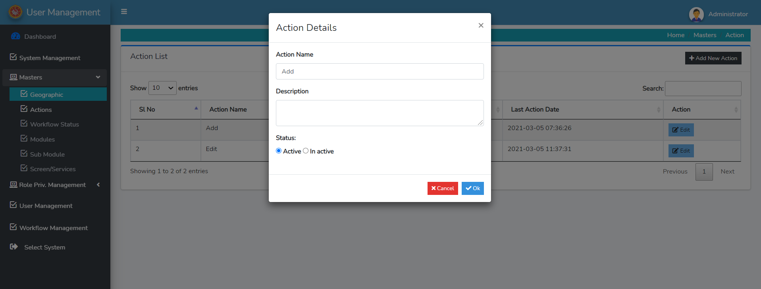

**3.2 Masters: Work Flow Status**

Step 1: Next Click on **Work Flow Status**. Upon click on this button, existing workflow status list will be displayed like show below

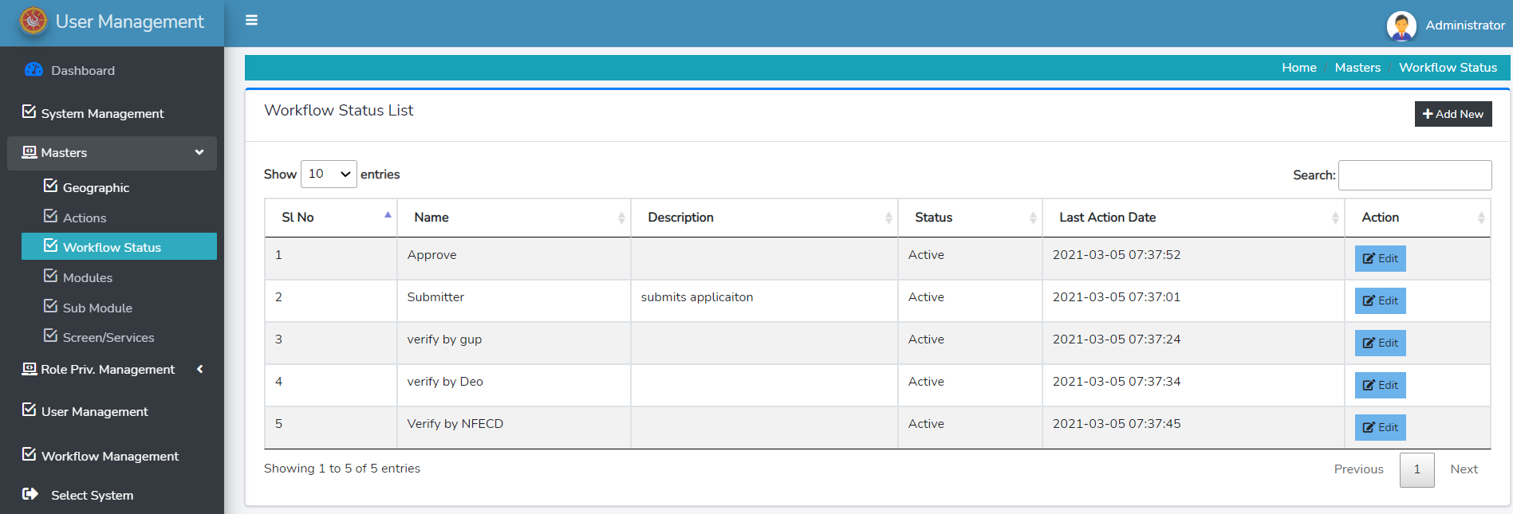

Step 2: Click on **Add New** to add new Workflow.



On click of **ADD NEW** button the form below will pop up. Fill in the detail and click **OK**

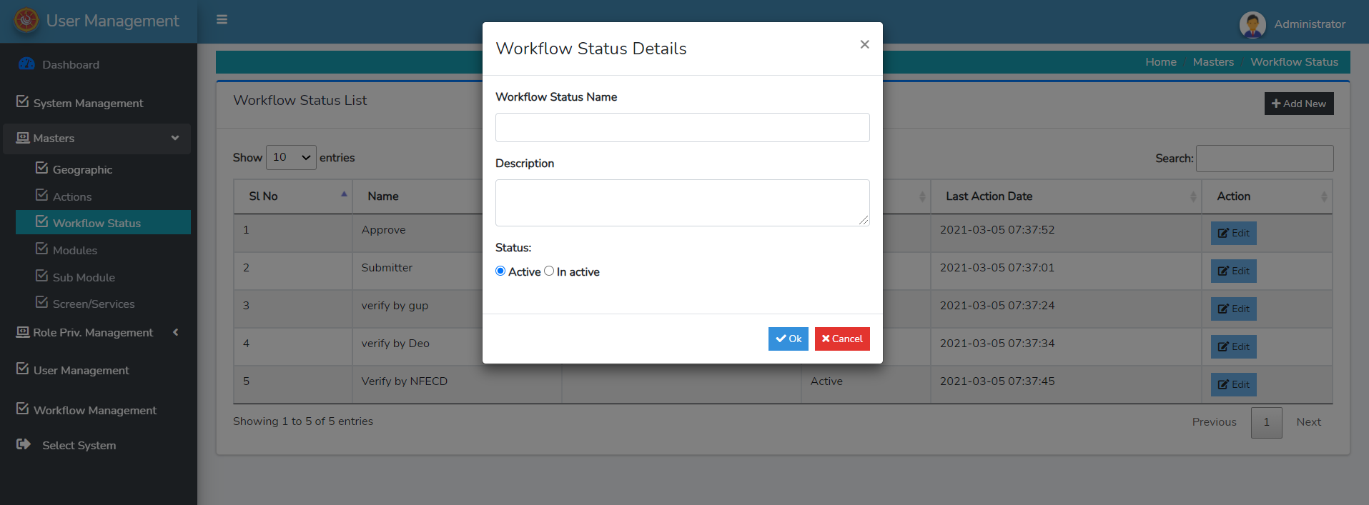

Step 3: click on **EDIT** to modify or change the existing workflow status. Click on **OK**

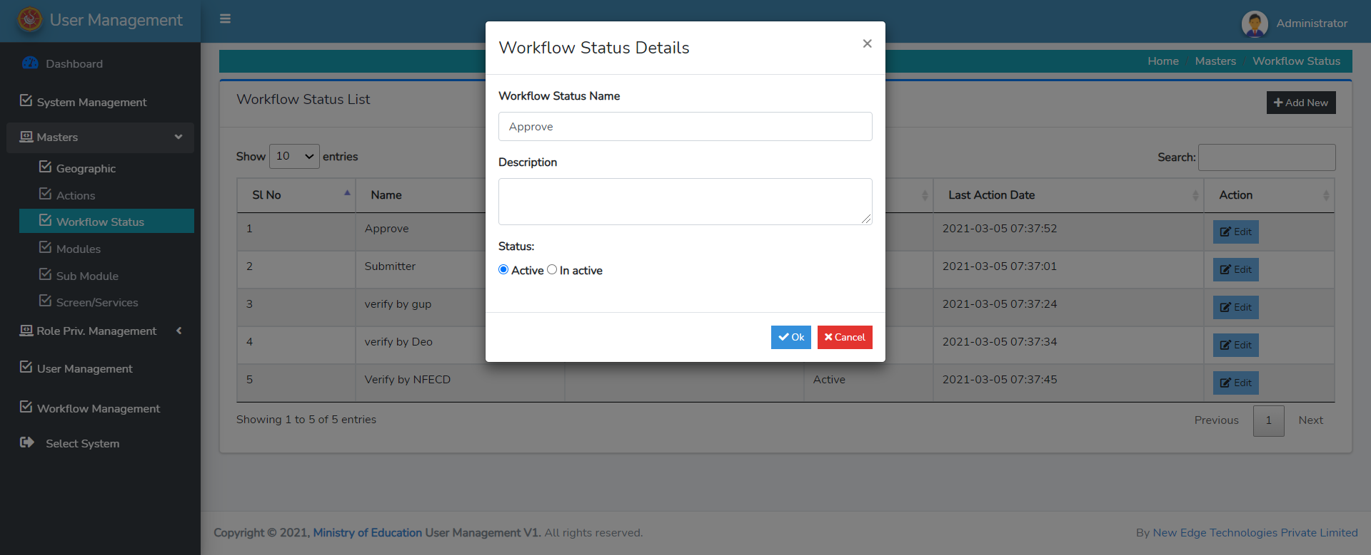

**3.4 Masters: Modules**

Step 1: Click on Modules to view existing Module List.

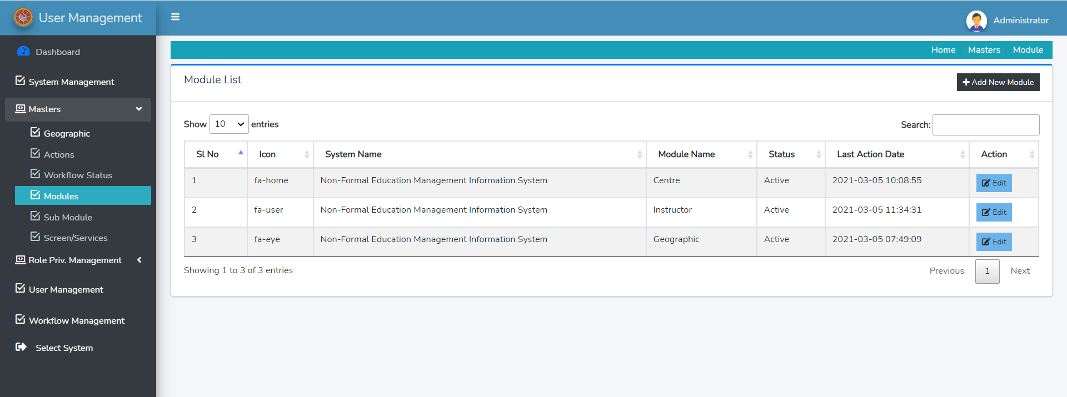

Step 2: Click on **ADD NEW MODULE** to add new module.



On click of **Add New Module** the form below will be pop up. Enter the related information and Click **OK**

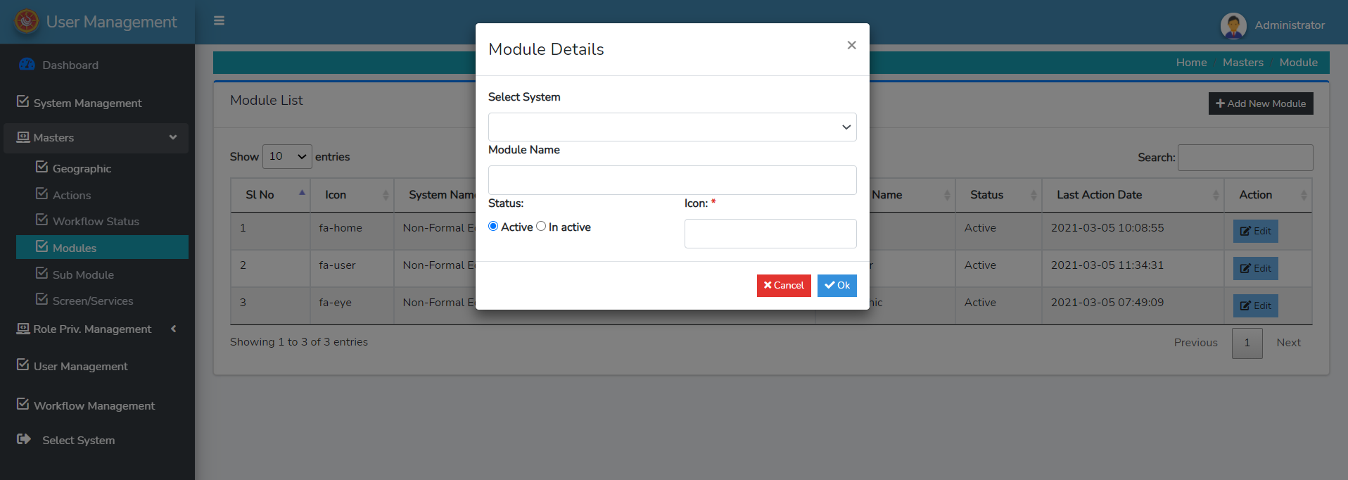

Step 3: Click on **Edit** Button to edit the existing module information. After click, a form will pop up, edit the required and necessary detail and then click **OK.** Note: the field marked star * are mandatory.



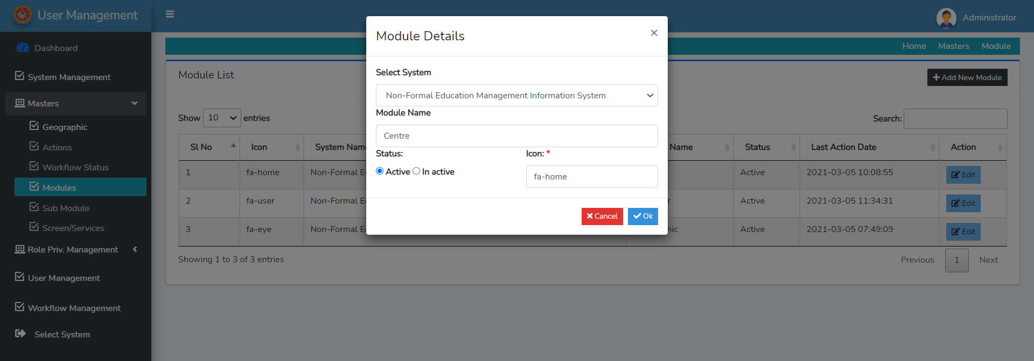

**3.5 Masters: Sub Module**

Step 1: click on Sub module button to view the list of existing Sub Module as show below.

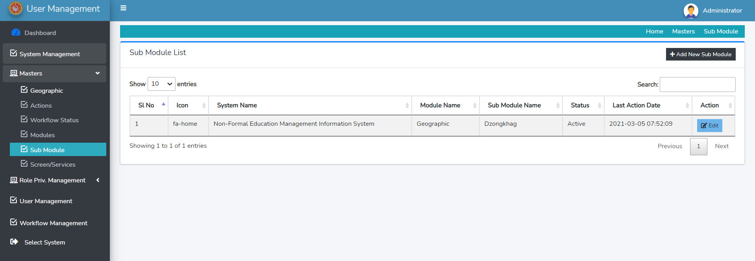

Step 2: Click on **Add New Sub Module** to add new sub module.



On click a form will appear, fill in the details and click **OK**

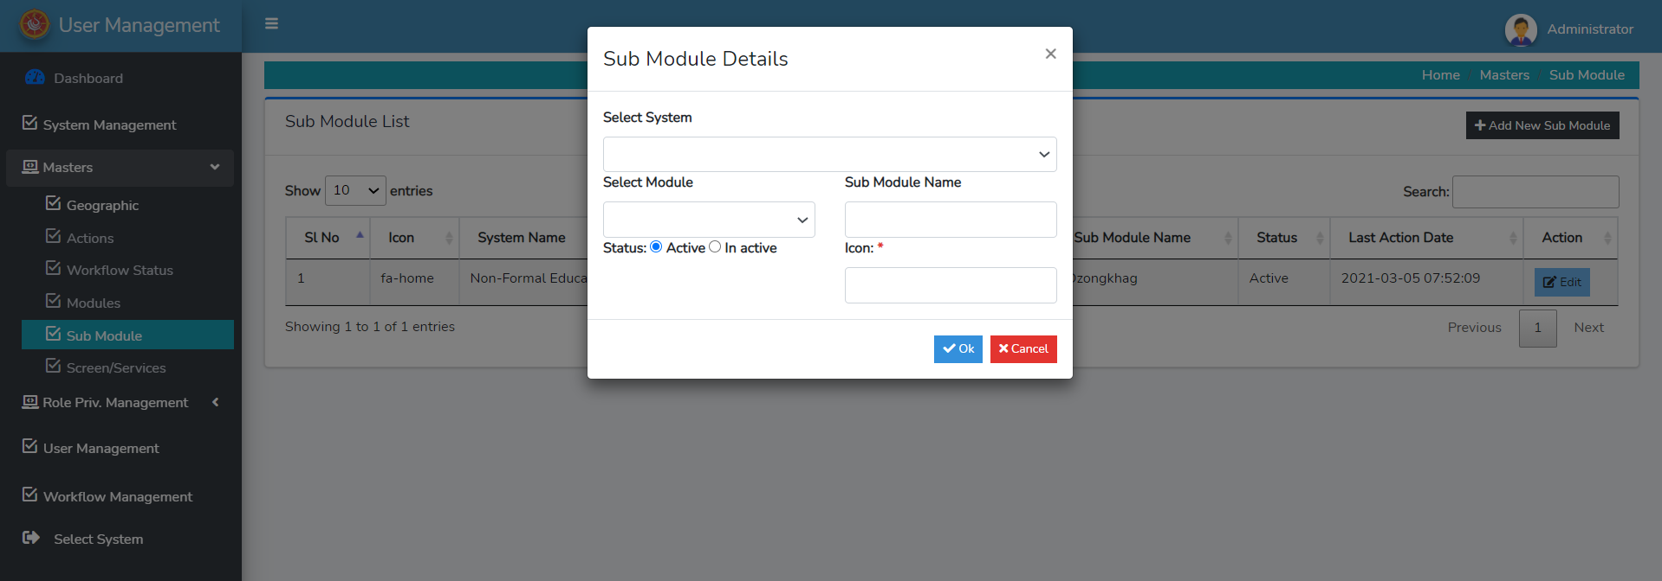

Step 3: Click on Edit button to change/modify the existing Sub module information.



Upon click on Edit Button an edit form will appear on the screen. Change the necessary information and click OK

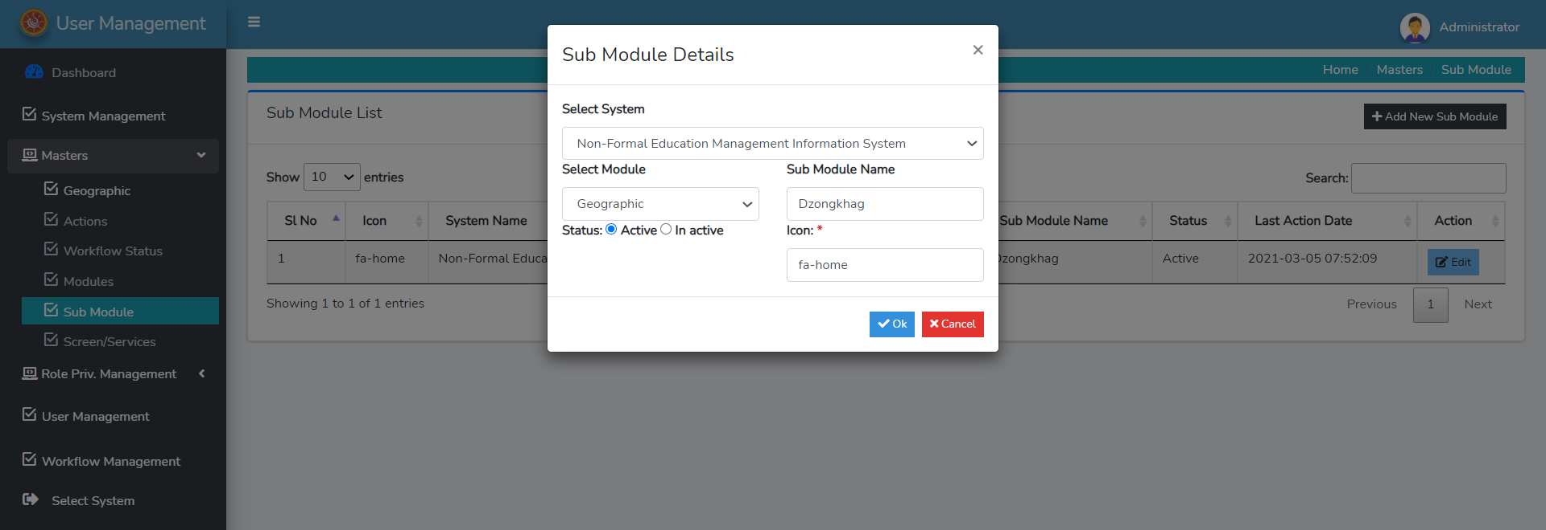

**3.6 Masters: Screen/Services**

Step 1: click on Screen/Screen to view the list of Screen and Services.

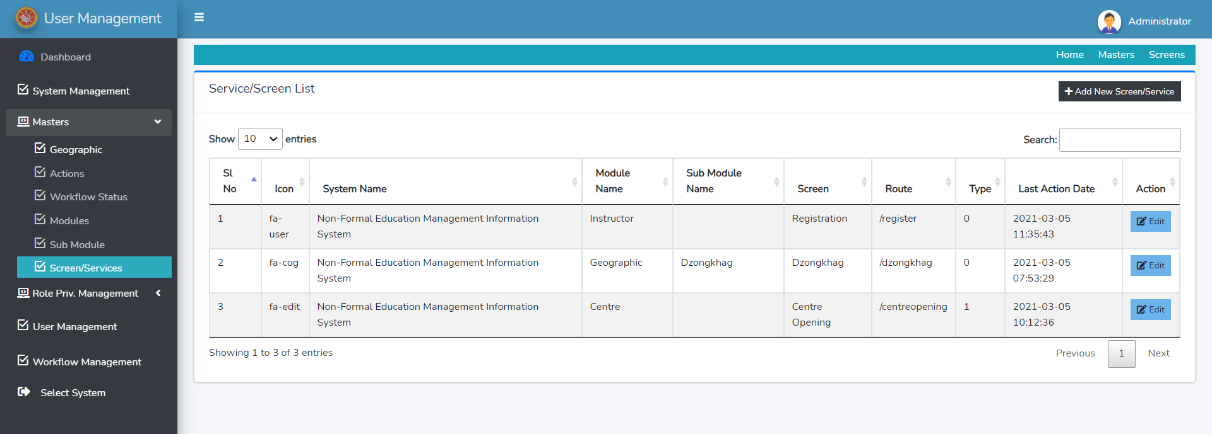

Step 2: To add new Screen/Services click on **Add New Screen/Services** show below



On click of **Add New Screen/Services** Button Add Screen/Service details form will pop up, enter information and click **OK**.

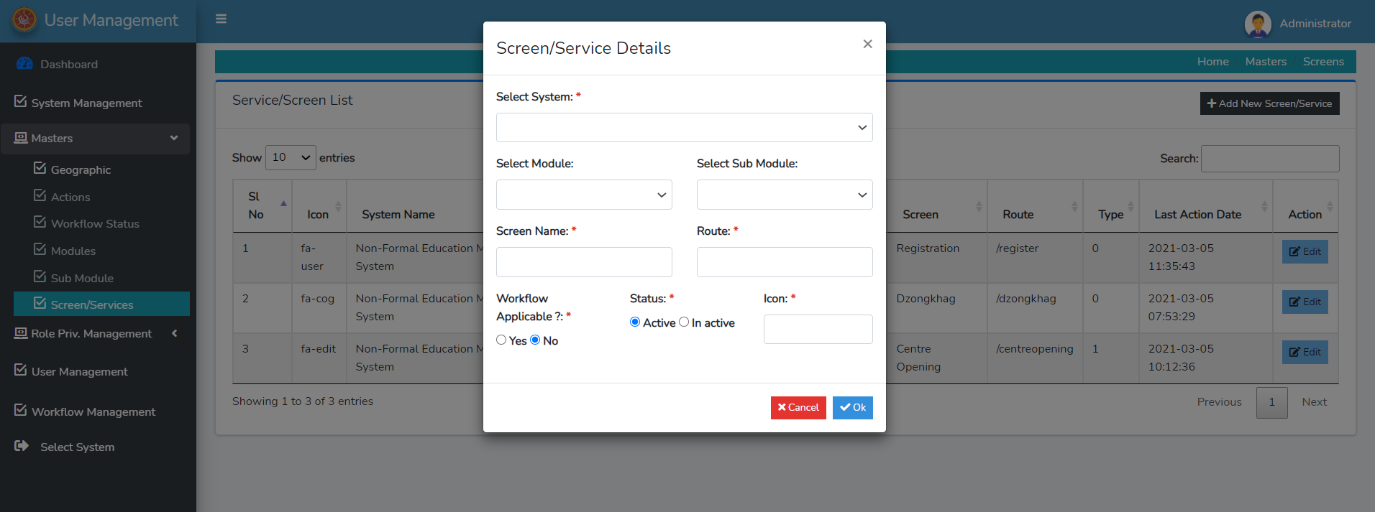

Step 3: Click on Edit Button to modify/changes the existing Screen/Service Information.

Upon click, a form will appear on your screen with existing detail, edit the necessary information and click **OK. Note:** the fields marked * are mandatory to be filled.

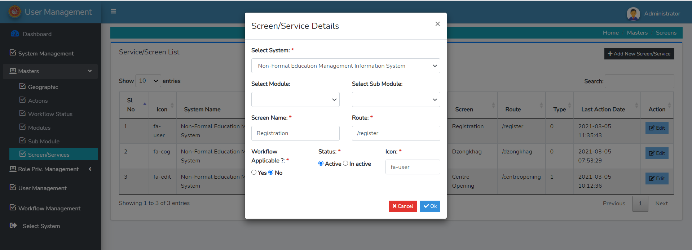

1. **Role & Privilege Management**

Upon click on **Role Privilege Management**, you will see **Role Management** & **Role Priv. Management**

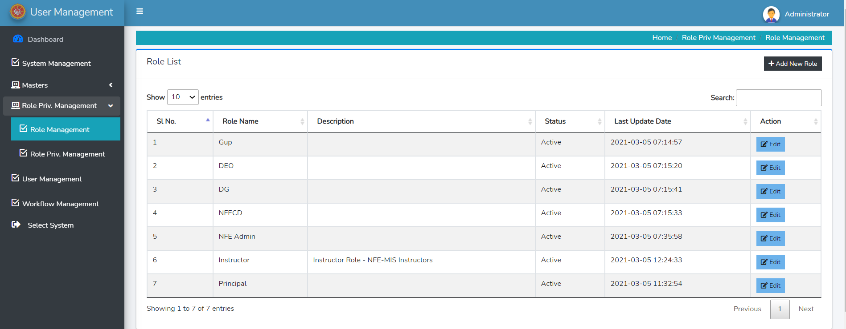

**4.1 Role & Privilege Management: Role Management**

Step 1: click on Role Management to view the list of Roles defined.



Step 2: to add new Role Click on Add New Role.



On click of **Add New Role**, the form below will appear, enter the related information and click **OK.** Make sure the field marked * are filled.

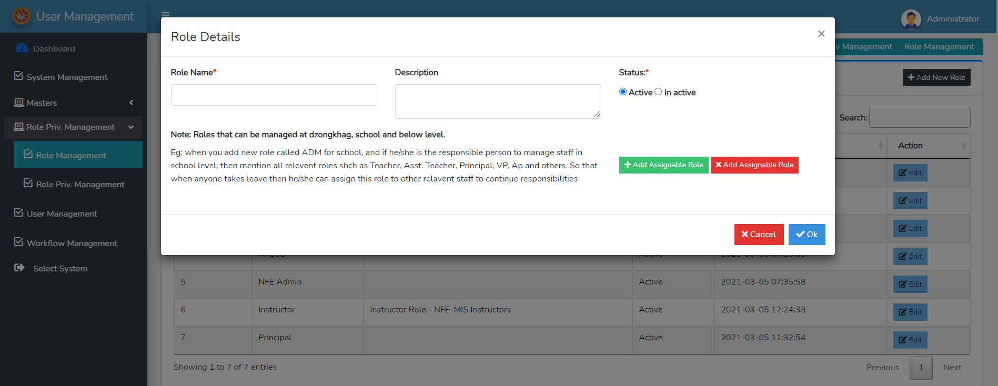

Step 3: to edit the existing defined role click on Edit button.



Upon clicking the Edit button, a form displayed below will appear on the screen, make the necessary changes and click **OK**

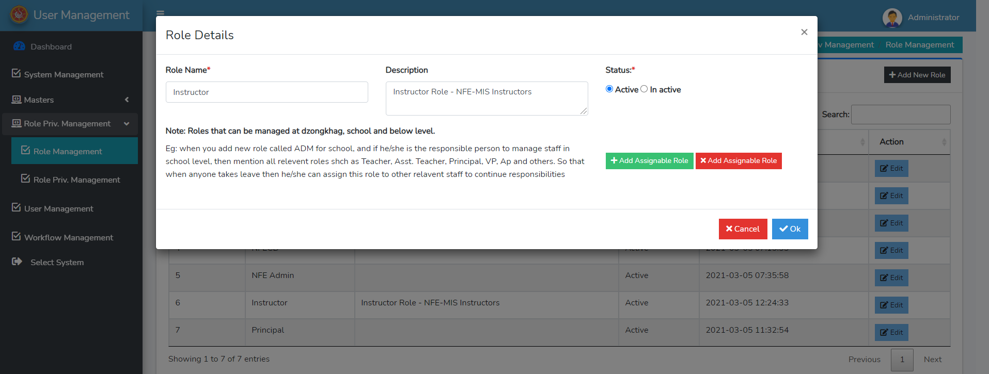

**4.2 Role & Privilege Management: Role and Privilege**

Role Priv. Management to map the system, Module, sub-module with role along with the level of action the selected role can perform in the system.

Step 2: click on role priv. management to map access level and action they can perform by the particular of roles in the system. Select role, system and its related module and sub- module to be mapped with and define level of action as shown below. After selecting the necessary field click on **UPDATE.**

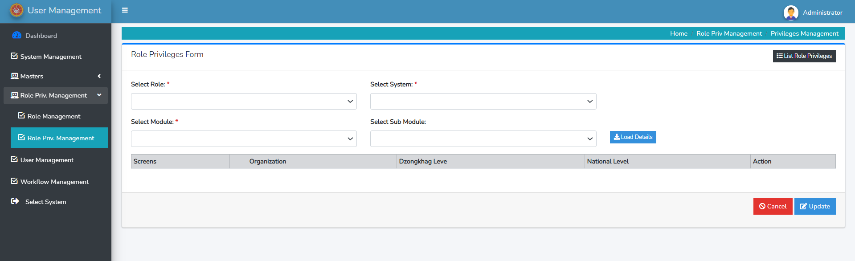

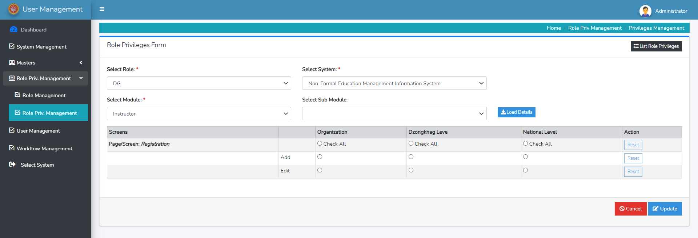

1. **User Management**

Step 1: Click on **User Management** to view the list of users along with their roles, system accessibility and other basic detail.

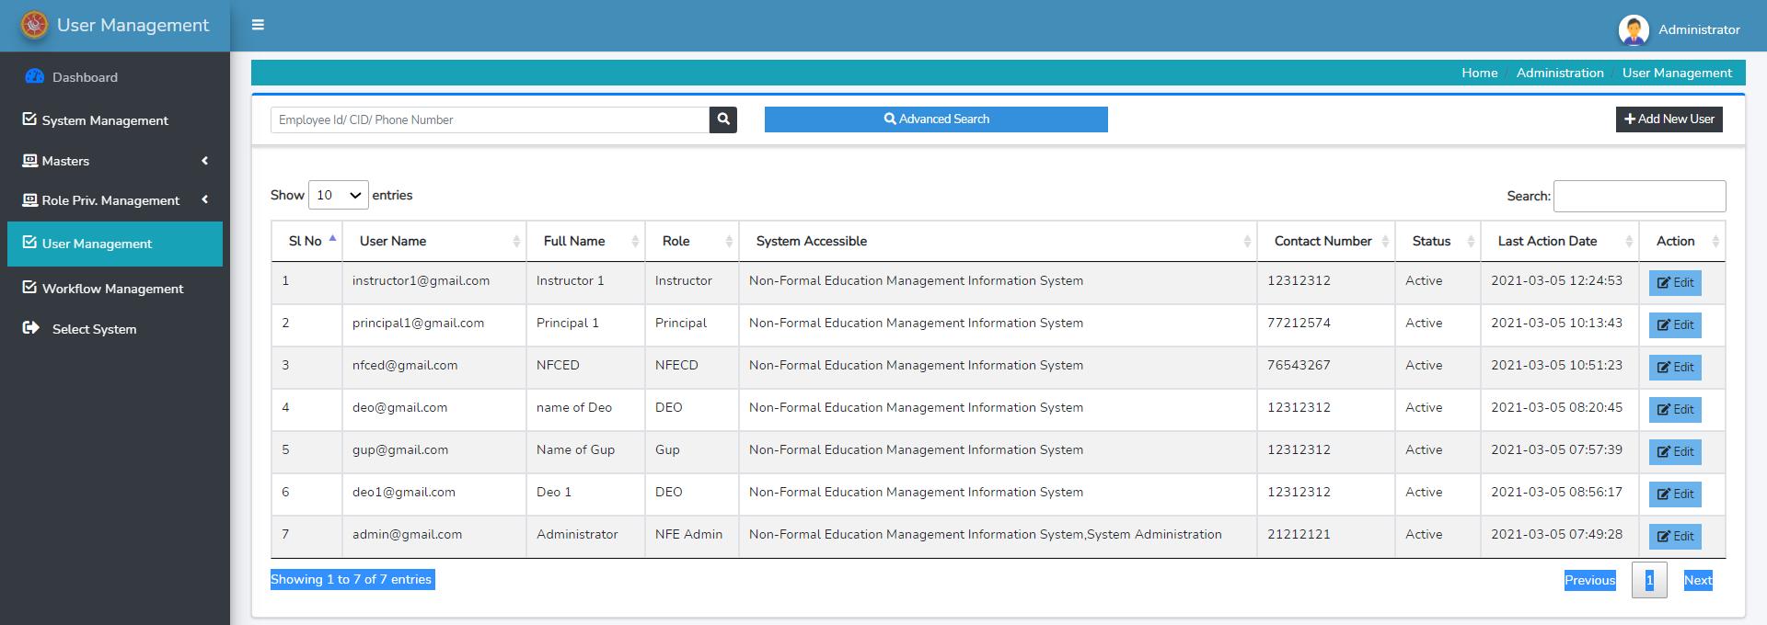

Step 2: To add new user and their related detail click on **Add New User** as shown below



On click of Add New User Button the form displayed below will appear on the screen, enter necessary details and click **Add/Update**

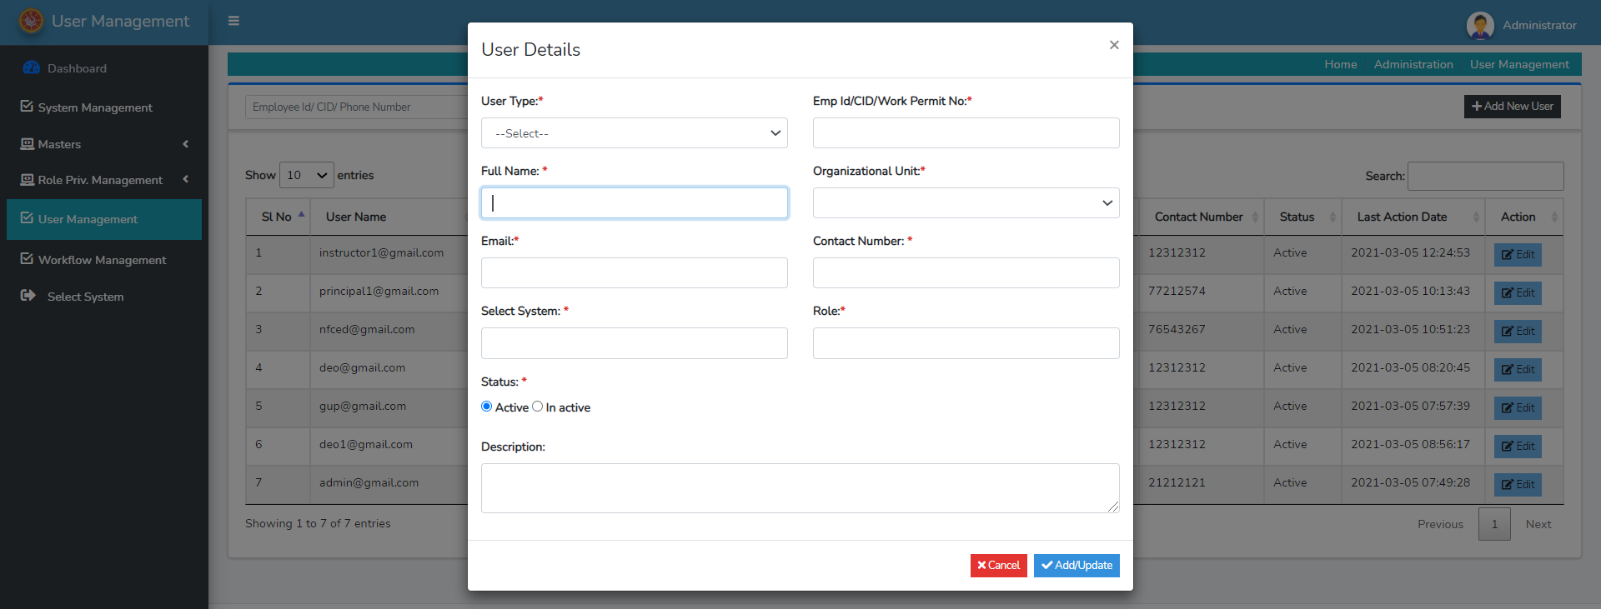

Step 3: Click on **Edit** to change/modify existing user management information.



On click of Edit Button the page below will appear, make necessary detail and click **Ok**

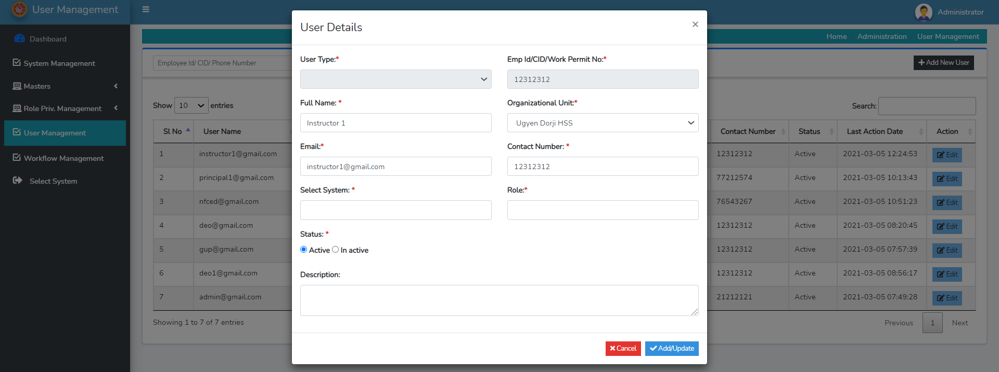

1. **Work flow Management**

Step 1: Click on Work flow Management to view the existing workflow defined in the system. The page below will appear on clicking.

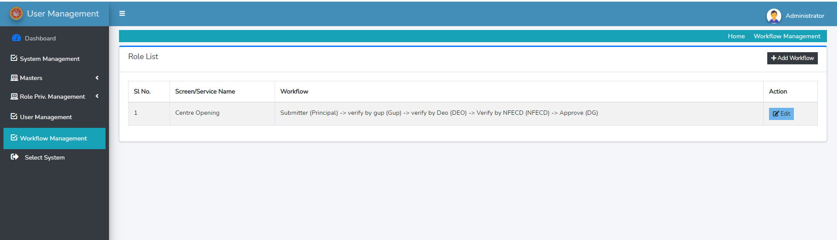

Step 2: to add new Workflow, click on **Add Workflow** as show below



On click of Add Workflow Button a form show below will pop up on the screen. Enter related information and click **OK.**

**Note:** one can also add more than one Authority type and roles based on the required workflow for the selected system’s screen/services, simply by clicking on add more option displayed on the screen.

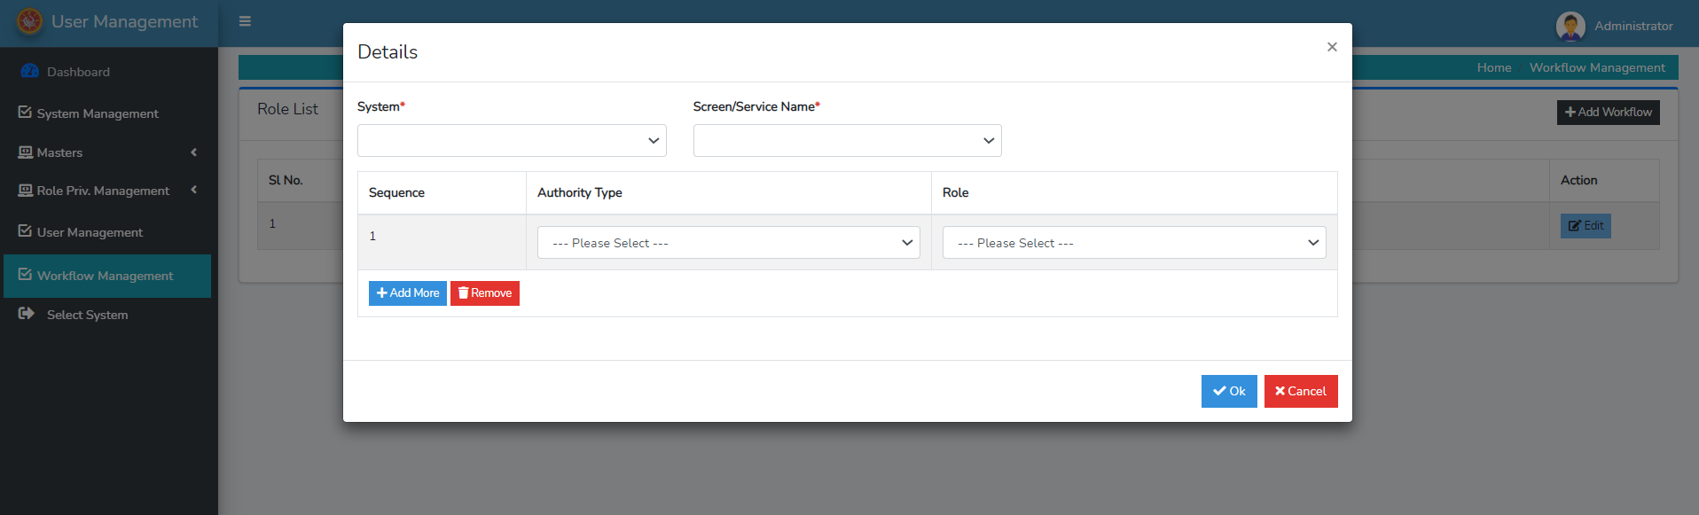

Option to add more authority type and roles

Step 3: Click on Edit button to change/modify the existing defined workflow as shown below



Upon clicking the form below will appear, make the necessary changes and click **UPDATE.**

